Quadcopter Design in Matlab

Table of Contents

① Why a drone is a drone? #how quadcopters generate motion 2

How we generate thrust, roll, pitch and yaw. They are decoupled to each other? 3

M.M.A. Motor Mixing Algorithm 4

② Control system architecture for an Autonomous Hovering Drone 5

#Exercise: how does it maintain position and altitude? 7

③ The process 8

④ Option2: Model-Based-Design – asbQuadcopterStart (Aerospace Package): The Whole Code 9

▨ asbQuadcopterStart: FCS block 10

▷ FCS block: Controller 11

• Inner ALTITUDE (thrust) controll 12

•• Inner yaw controll 12

••• Inner Roll and Pitch controll 12

•••• Outer (Position xy ground control) (ROll and Pitch outer Controll) 12

▷ FCS block: State Estimator block 13

• Sensor Processing 13

•• Blending the measurements together 14

▷ FCS block: Fault protection block 14

▷ FCS block: Landing Logic block 14

▷ FCS block: Data logging block 14

▨ asbQuadcopterStart: DRONE DYNAMICs block 16

▨ asbQuadcopterStart: SENSOR DYNAMICs block 17

▨ asbQuadcopterStart: ENVIRONMENT block 17

Reference YouTube playlists:

→ Quadcopter Design Matlab

<https://www.youtube.com/watch?v=hGcGPUqB67Q&list=PLPNM6NzYyzYqMYNc5e4_xip-yEu1jiVrr&pp=iAQB>

# ① Why a drone is a drone? #how quadcopters generate motion

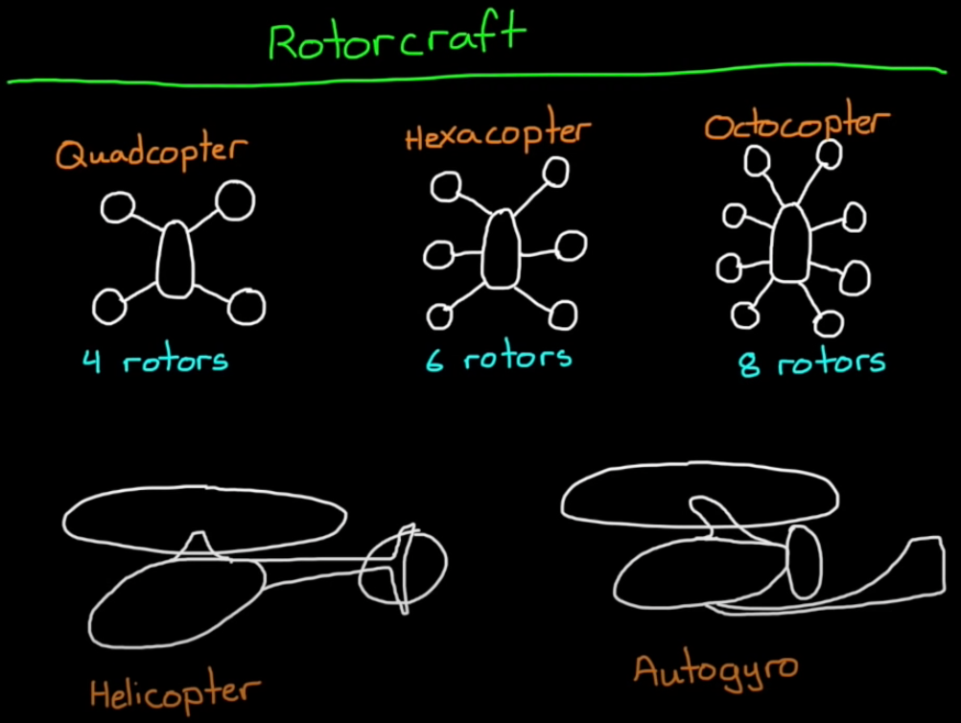A quadcopter is named so because of its 4 propellors. In the same way you could add other rotors, and they would be called like hexacopter (6 rotors) or octocopter (8 rotors). In any case they all are part of the big family of **ROTORCRAFT**, to which it also belongs also the helicopter. While they are all rotary vehicles, they have different dynamics and therefore different control strategies.

• Hardware of a minidrone: sensors

On the back of the drone, there are usually two kind of sensors:

* **Ultrasound sensor**: used to measure vertical height distance. It works by sending a high frequency pulse and measure how long it takes to bounce on the floow and come back to sensor. From the measure time distance between floor and drone can be calculated. It’s usually precise up to 9/10meters, than the reflected sound is too weak to be picked up by the sensor.
* **Pressure sensor**: indirectly measure of the altitude, used above the 10meters thanks to the change of pressure.
* **Camera**: takes images usually up to 60 frames for seconds. It’s uses an algorithm called optical flow to determines how images are moving between one frame to the next. Thanks to this the minidrone can determine horizontal motion and speed.
* **IMU (Inertia Measurement Unit)**: it’s made by 3-axis accelerometers that measure *linear acceleration* (x,y,z) ad a 3-axis gyroscope that measures the *angular rate* (roll, pitch and yaw).  
  From the IMU and our knowledge of acceleration due to gravity we can estimate the minidrone **attitude relative to gravity** and how fast It’s rotating.

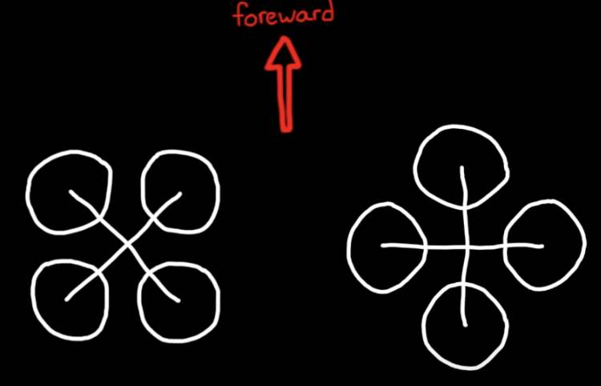•• Hardware of a minidrone: actuators

The configuration of the actuators and their spin direction is relevant to the type of dynamics we have to control.

Two important things:

1. **Layout configuration**: Usually what’s commonly used it’s an “H” configuration of the motors rather than a “+” configuration. The only difference between the two is to which motors you send command to when you are pitching or rolling the drones.
2. **Spin configuration**: Opposing motors spin in the same direction to each other, but in opposite direction as the others pairs. *This is necessary to make sure that thrust, roll, pitch and yaw can be commanded independently to each other*.

••• Overview of the control problems:

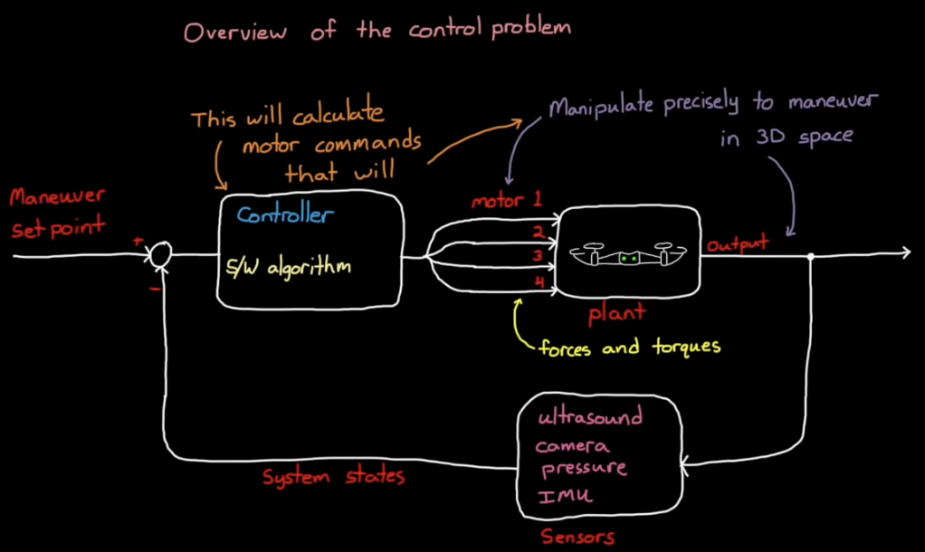The **plant** is our drone itself, and we have **4 actuators** that inject forces and torques in the system. The question is how we inject forces and torques in our system, so that the output in 3D space is the result we want?

To close the loop, we have a set of sensors that are used to directly or indirectly estimate the **system states** of the drone. System states are things like angular position and rates, altitude and horizontal velocity, and the system states we are measuring depends on the control system architecture and what we are trying to accomplish.

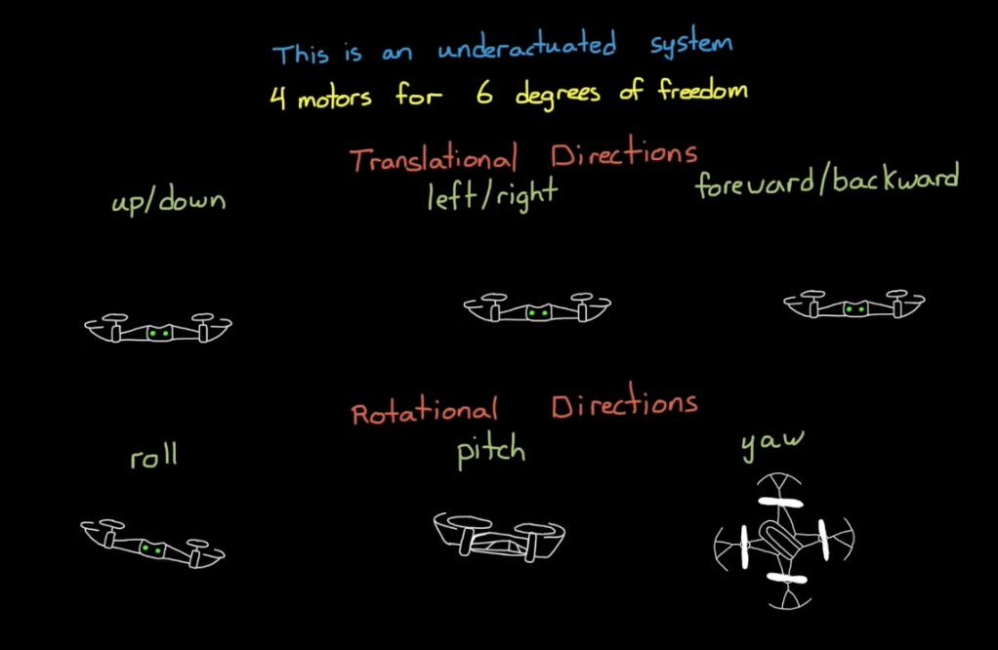Finally depending on the system stats, and the **manoeuvre setpoint** (what we want our drone to do) we can develop a **controller**, basically an algorithm that run on software that takes in our setpoint in estimate states and calculate the precise motors command that will inject the necessary forces and torque into the plant.

**BUT.**

The drone is an underactuated system, because we have 4 motors for 6 degrees of freedom. And since we do not have an actuator for every motion, then some directions are incontrollable at any given time.

Moving forwards backwards and move left and right are our unactuated motions.

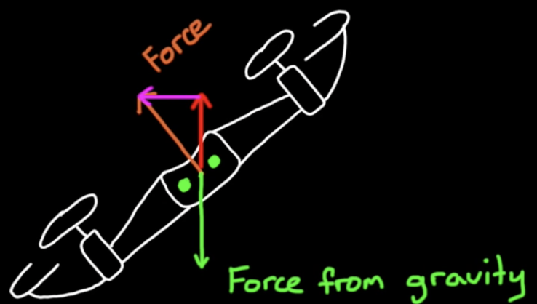The way we get around that is by first rotating into an attitude where the thrust vector is partially in the gravity direction and partially in the direction of travel. Now if we wanted to maintain altitude while we do this manoeuvre we need to increase the thrust so that the vertical component is still cancelling out the downward pull of gravity  
The underactuated problem control it’s solved by developing a control algorithm that couples rotation and thrust to accomplish the overall goal.

### How we generate thrust, roll, pitch and yaw. They are decoupled to each other?

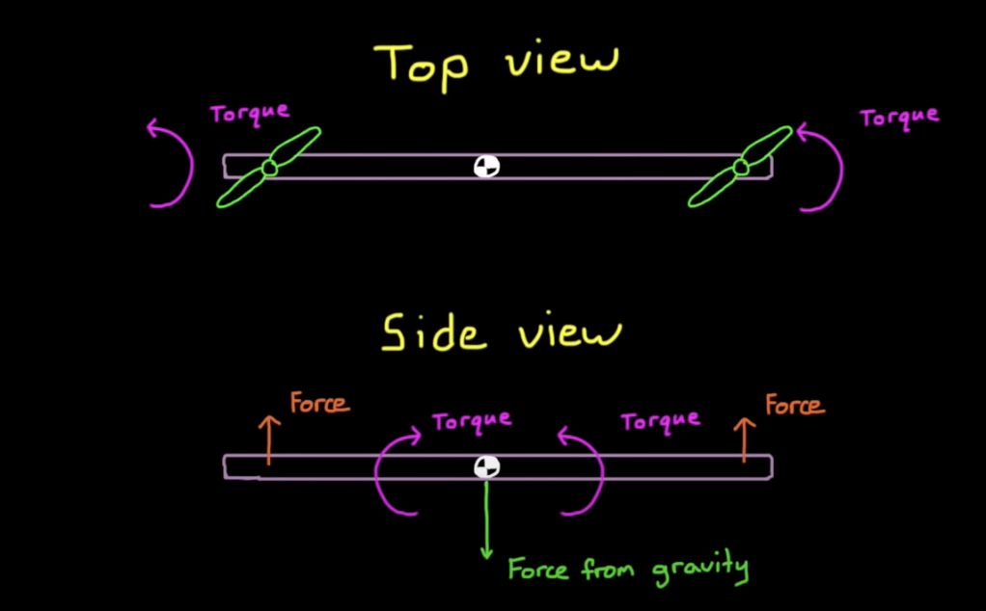We start with just a bar. By using two rotors spinning in the same direction, due to the reaction torques over the bar itself, it would start spinning in the other direction.

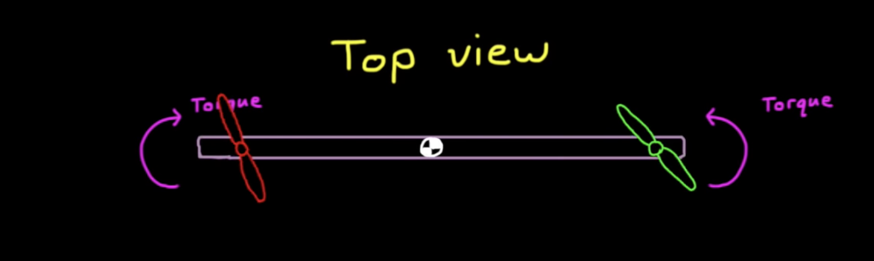Than we make opposite -spinning motors.

Now the bar it’s balanced if their sum of torques is balanced, and it can “yaw” if they are unbalanced. If their sum increases equally, it starts rising “thrusts” because the resultant force increases, and viceversa if they spin slower together it starts lowering.

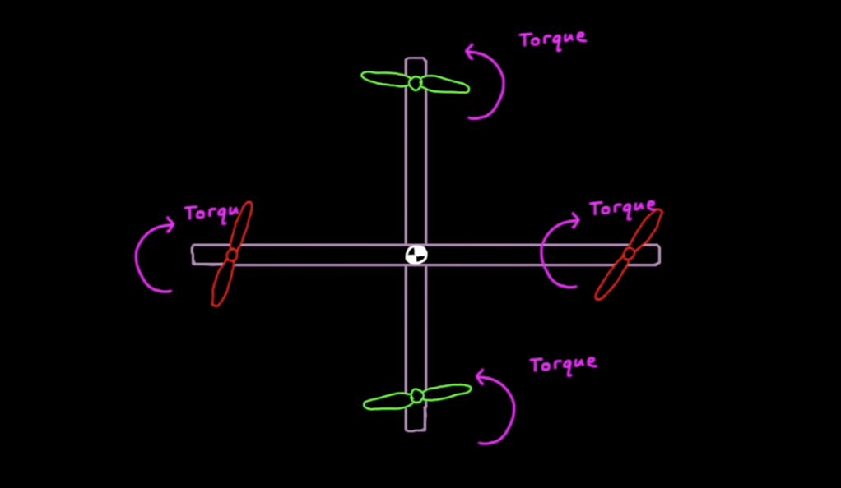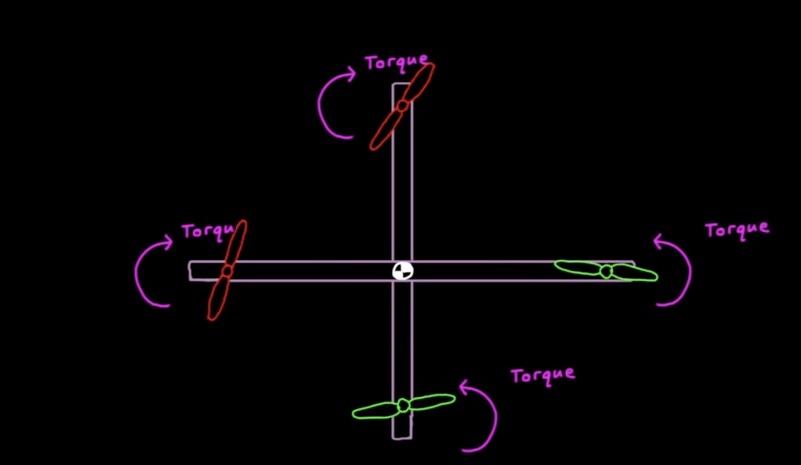BUT how we can roll the bar? Simply, we add a second bar *→ [ QUADCOPTER GENERATED ]*

With this configuration we can hover when at least each one them produce ¼ the one of gravity (accelerating each motors in the same way). To change **THRUST** we have to simplyincrease or decrease all motors simultaneously.

We can avoid “yaw” by using two counter-spinning motors. It’s not necessary that are in opposite direction, as long there are two in the same direction and two in the other direction. But controllers set with opposite-spinning motors, why?   
It is because this configuration allows to decouple yaw with roll, pitch and thrust.

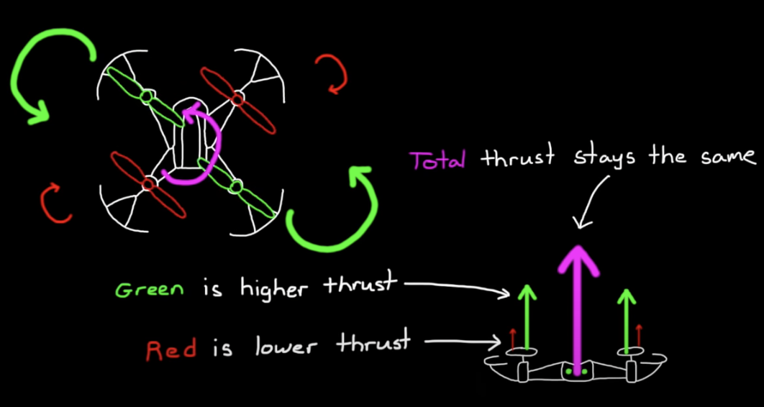  
To see this, let’s see how we could control **YAW** with a quadcopter with opposite-spinning motors.

If we want to have the vehicle yaw we have to:

1. Speed up the motors rotating in the opposite direction respect the one we want to yaw. This is due to the conservation of the angular momentum
2. Slow down the other motors spinning in the other direction.

In this way we can maintain the same thrust (without rising or lowering), same roll (we are not rolling) but the torque is different and therefore we can yaw.

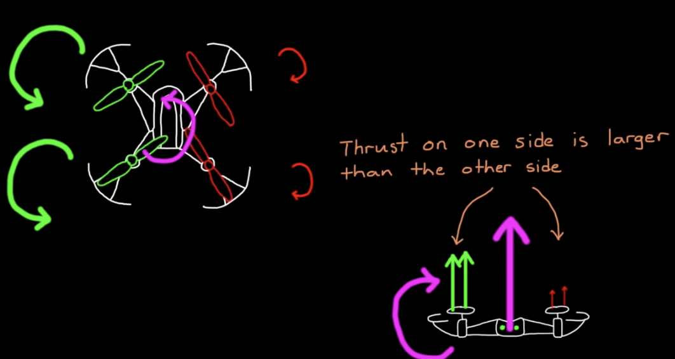

If the rotating motors are on the same side, than makes one pair slower and increase the other will create an unbalance of forces respect the center of gravity, therefore making the drone to roll or pitch depending on which side they are on.

The same works also for pitch and roll. With opposite-spinning motors:

* we can **ROLL** by increasing **same side** **opposite spinning direction** motors and lowering the other pairs of the same amount, so that
* We can **PITCH** in the same way but by increasing the **same front opposite spinning direction** motors and lowering the other pairs.

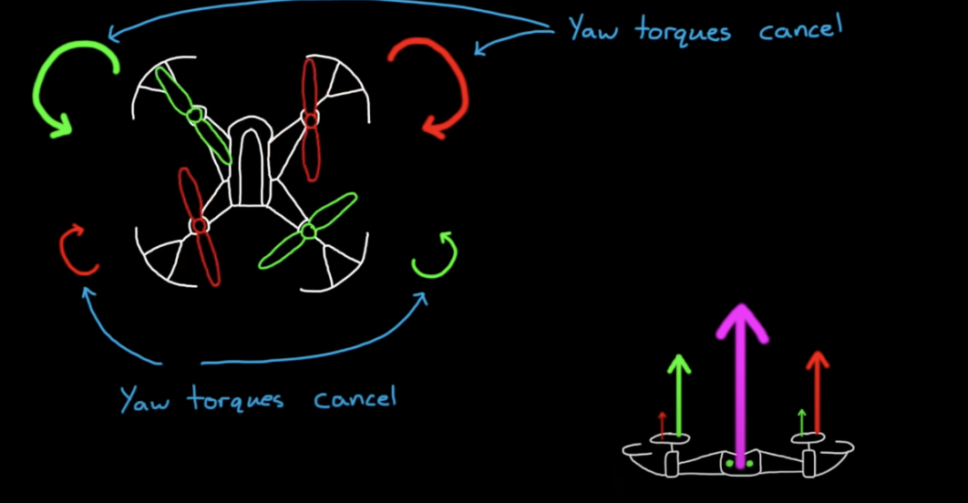 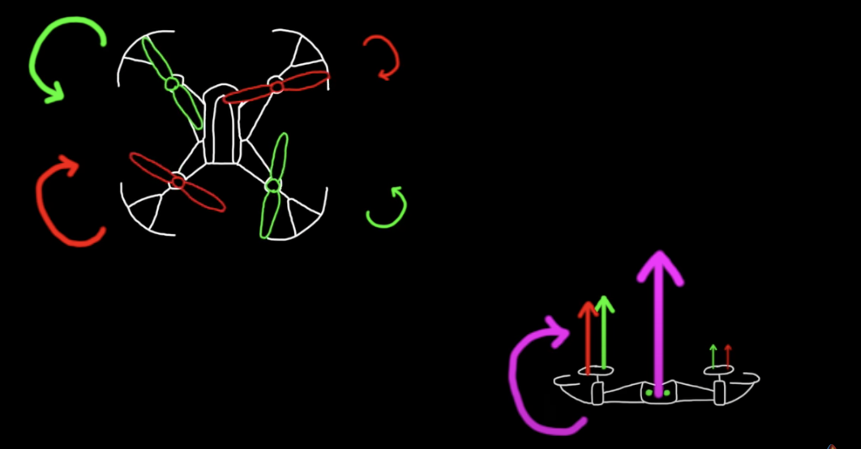

Both of this motions will have no effect on yaw since their yaw torque will continue to cancel each other out.

*→ [ SPIN CONFIGURATION GENERATED ]*

### M.M.A. Motor Mixing Algorithm

IN THIS WAY, pitch, roll, yaw and thrust are the 4 directions in which we have control over.

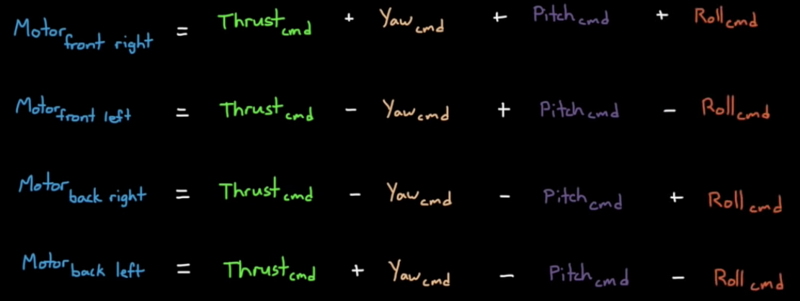The commands to the motors will be a mix of the amount of pitch, roll, yaw and thrust required.

1. **THRUST**:  we can command thrust by setting all four motors to the same speed.
2. **YAW**: we increase two motors spinning in the same direction and decrease the other two
3. **ROLL**: is created by increasing or decreasing the left/right motor pair
4. **PITCH**: is the same by increasing or decreasing the left/right motor pair

This is our simple **MOTOR MIXING ALGORITHM** that is valid for many quadcopter configurations, including both the "H" and "+" layouts.

**•• WHY DO WE NEED A M.M.A.? → To make our life easier.**

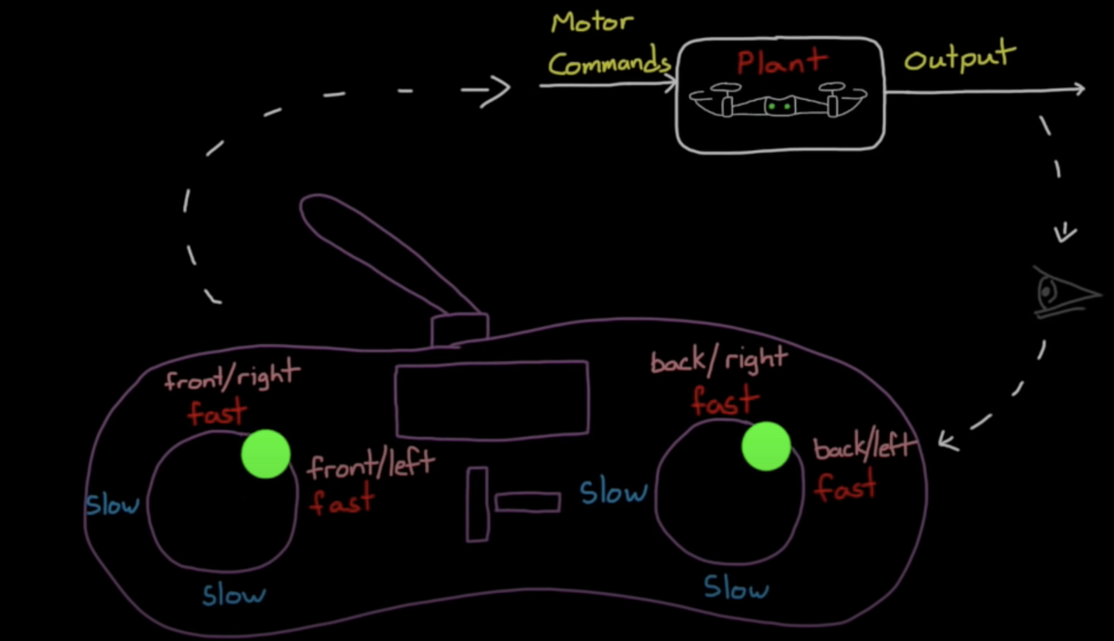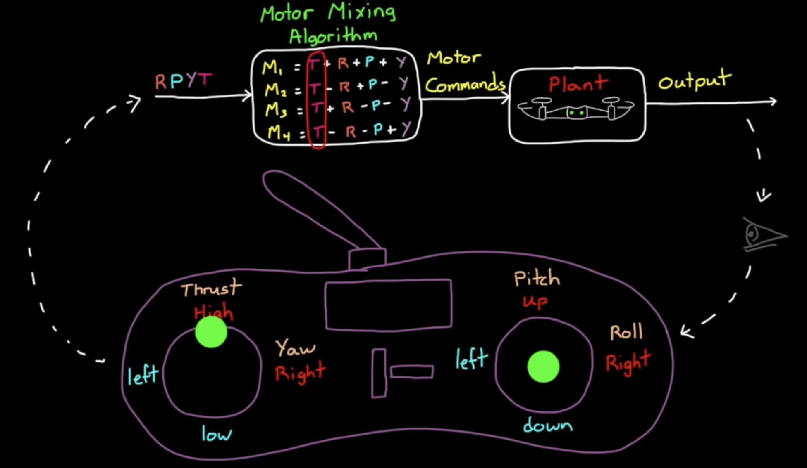The M.M.A. can convert between the less intuitive motor speeds in a more intuitive roll pitch yaw and thrust. This simplification is self-explanatory by looking at the pictures on the right, where we insert ourself in the closed loop with a remote control where we try to rise the drone by increasing the thrust.

Thinking in terms of R, P, Y and T is beneficial not only for driving the drone but also for controlling the drone. So that the MMA will be kept in the control architecture.

*→ [ MOTOR MIXING Algorithm GENERATED ]*

# ② Control system architecture for an Autonomous Hovering Drone

Let's get rid of the human operator and think about how we can accomplish the same thing autonomously. We'll start by focusing on the thrust command.

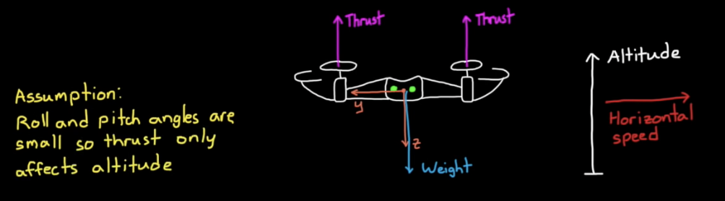 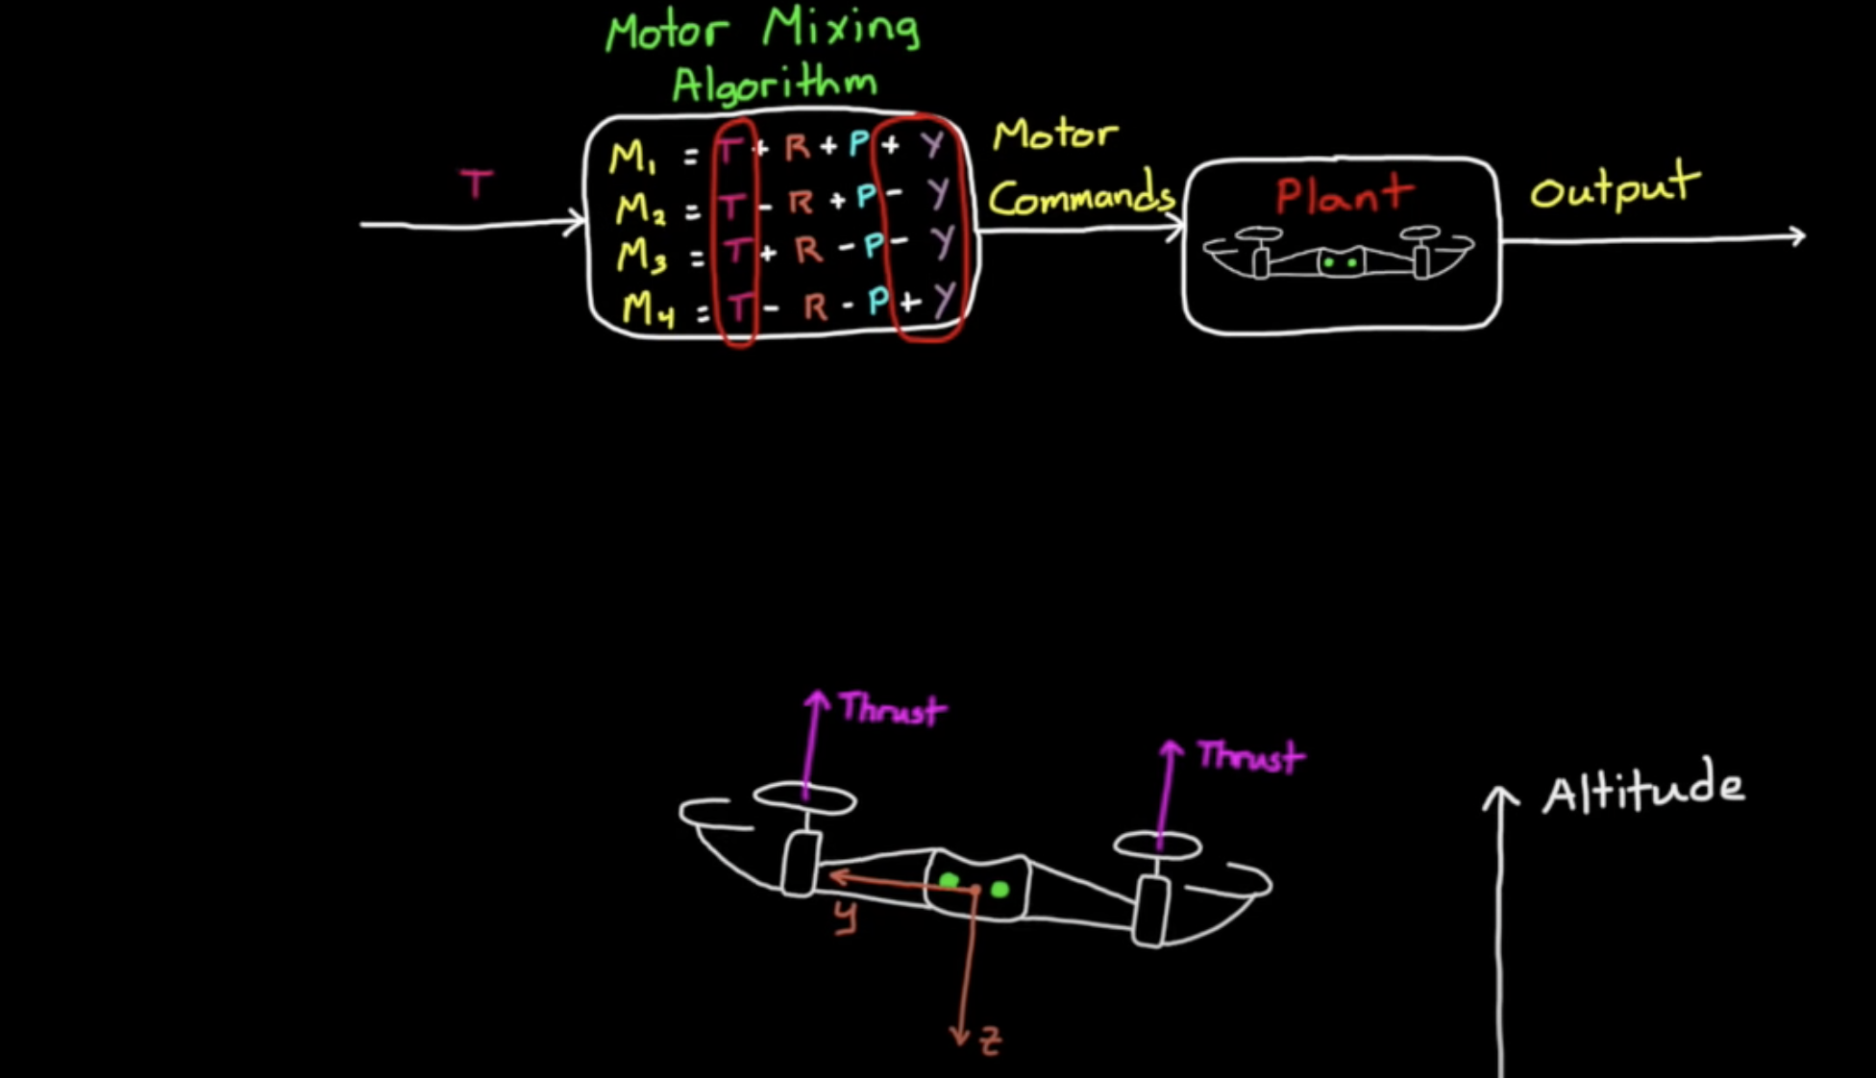 • THRUST CONTROL

Thrust is always in the same direction relative to the drone airframe (along the z axis of the drone).  
That means that if the drone is flying levelled (→ the z axis is aligned with the gravity vector) then:

* increasing thrust causes the drone to increase its altitude rate (how fast it's rising)
* decreasing thrust drops the altitude rate.

The **assumption** for this to be true is that: the roll in pitch angles are always really small in this way changing the thrust only meaningfully impacts altitude rate and nothing else. This assumption for example falls behind when talking about racing drone, which are usually in steep angle of rolling and pitching and *thrust is coupled to both altitude rate and horizontal speed*.

Let's build a controller that uses thrust to adjust the altitude if we're able to measure the drone altitude then we can feed it back to the closed loop and compare it to an altitude reference. The resulting error is then fed into an altitude controller (for example a PID) that's using that information to determine how to increase or decrease thrust.

* if the drone is hovering too low the altitude error will be positive, and the thrust command will increase causing all four motors to speed up at the same time and the drone will rise.
* 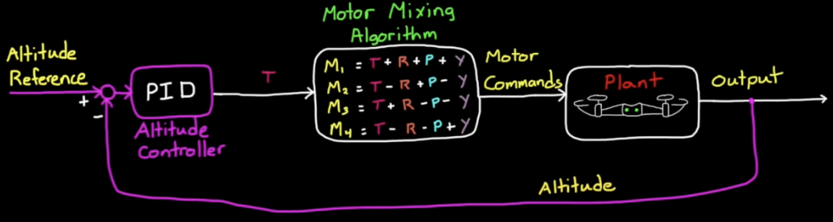if the drone is too high then all four motors will slow down so that the drone will descend.

However there are disturbances like wind gusts that will induce a little roll or pitch into the system and when that happens the thrust will not only adjust altitude but also create some horizontal motion and the drone will start to move away from you. And what good is a hover controller that maintains altitude but requires you to chase after it? So we should start by trying to maintain level flight by controlling roll and pitch angles to 0 degrees so thrust once again will only impact altitude and the drone won't wander away.

•• THRUST ALTITUDE CONTROL is not enough, than we add ROLL, PITCH, YAW TO MAINTAIN 0°

*We know that we're able to command thrust roll pitch and yaw independently: that is we can command one action without affecting the others*.

$$↓$$

Knowing this we can create three more feedback controllers one for roll pitch and yaw exactly the same way that we did for thrust. The output of the plant it becomes more than just altitude: so that we're also going to need to measure or estimate the *roll* *pitch* and *yaw* angles as well.

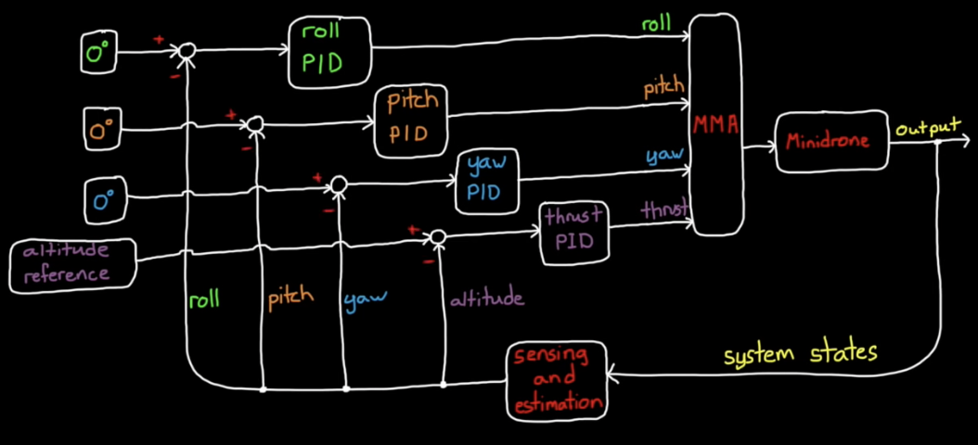We have four independent or decoupled controllers:

* One for **thrust which is really an *altitude controller*** since we're claiming small role in pitch angles
* Then **three controllers that are trying to zero degrees in roll pitch and yaw respectively.**

This should maintain altitude and it should keep the drone facing forward and level with the ground now.

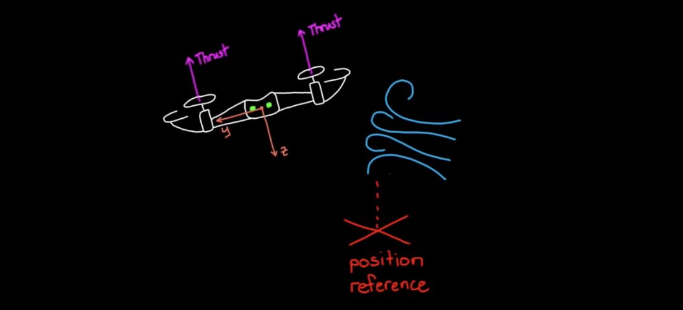•• T, P, R and Y are not enough. We need a cascade control with an outer GROUND POSITION CONTROL.

This is obviously a better hover controller than our first one but again it's still not perfect.

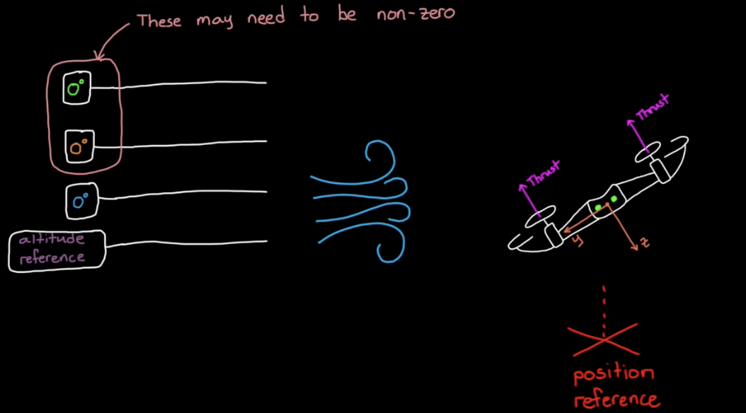 If our wind gust might initially introduce a little roll angle, our roll controller will remove that error and get the drone back to level flight however for a very brief time during the roll the thrust vector is not straight up and therefore the drone will have moved horizontally a little bit.  
  
There's nothing in our control system architecture that will bring the drone back to its starting position. So let’s improve it.

Role and pitch while hovering it's tempting to say that should be zero and that's how we set up this current version of the controller however **they may need to be nonzero in order to hover**. For example if we want to hover in a strong constant wind then the drone will have to lean into the wind at some angle to maintain its ground position.

So rather than specifying that we want levelled-flight really what we need is a **GROUND POSITION CONTROL**: so something that will recognize when the drone is wandering off and make the necessary corrections to bring it back to the reference point x,y.

But just because we don't want to pick specific role in pitch angles that doesn't mean that we don't need the roll in pitch controllers. Remember that a quadcopter is an underactuated system, so to move forward/backward it first rolls or pitches into the desired direction of travel. So that our control system needs to couple position errors with roll and pitch.

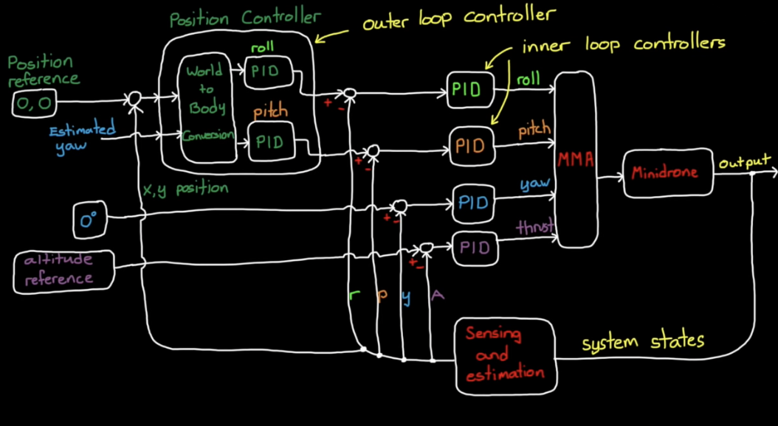We can solve this problem by feeding back that drones measured XY position and compare it to the reference to get the *position error*. For now, let’s say that the reference position is zero, in this way our controller will cause the drone to hover right above the take-off point.

Now our position controller takes the **position error** as an input and then outputs **roll and pitch angles.** These will be the reference angles that ROLL and PITCH controllers in the inner loop must try to follow.   
In this way the position controller is the outer loop and it's generating the reference commands for the inner loop roll and pitch controllers: these are cascaded loops. [→ *CASCADE PIDs CONTROL GENERATED* ]

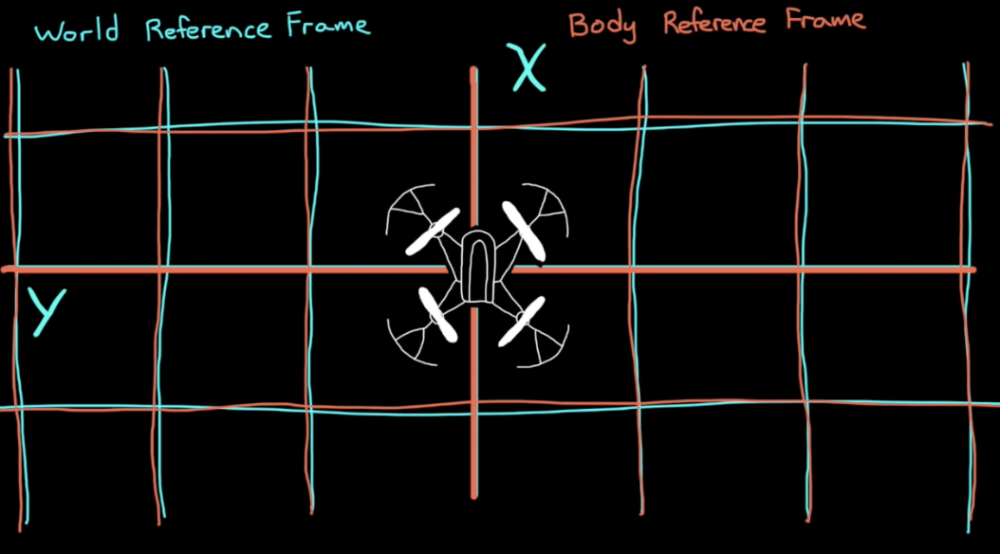**••• NOTE**: The **measured yaw angle also feeds into the position controller**

The reason very is that the XY position error is relative to the world reference frame, whereas roll and pitch are relative to the body of the drone.

* 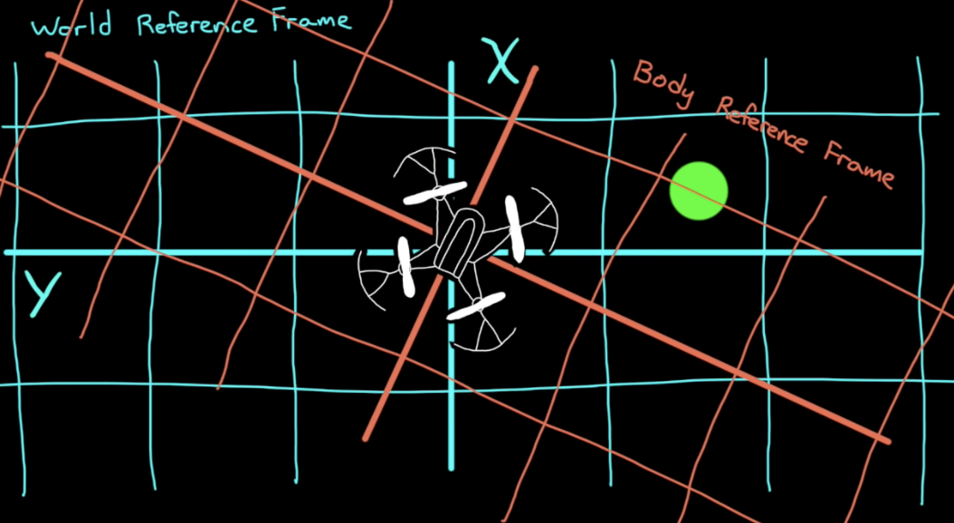This means that PITCH doesn't always allow the underactuated drone motion in the X-world direction and ROLL doesn't always move the drone in the Y world direction.   
  It depends on how the drone is rotated (the yaw angle)
* So if we need to move the drone to a very specific spot in the room (green spot in the picture), it needs to know YAW in order to determine whether ROLL, PITCH or some COMBINATION of the two is needed to achieve that.

So our position controller uses YAW to convert between the world XY frame and the body XY frame.

#### #Exercise: how does it maintain position and altitude?

* Let's say that the drone is flying level at the correct altitude but a little too far left of where it took off.

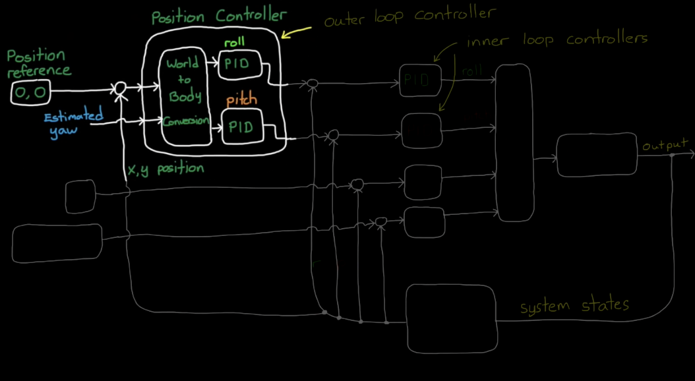This will result in a position error that feeds into the POSITION CONTROL.   
The YAW angle will be used to be aware of the body/ground relative position.   
The proportional part of the controller will multiply that error by a constant which will request that the drone roll to the right by a certain angle. The role controller will see that there is a roll error because the drone is still levelled and request a rolling torque.

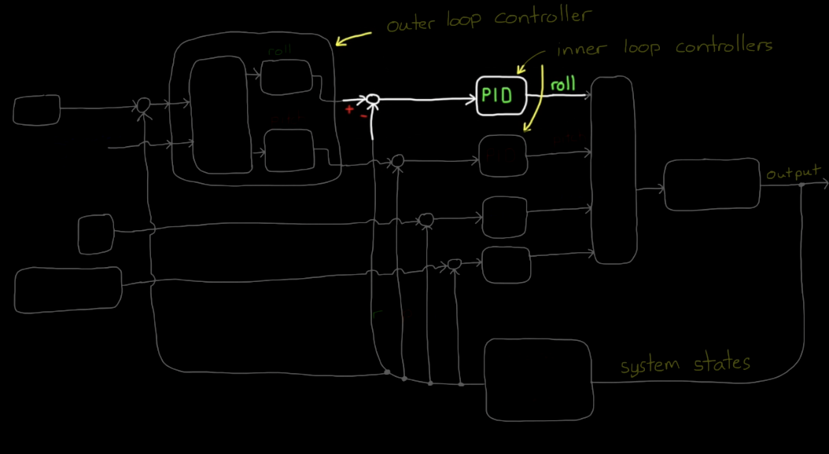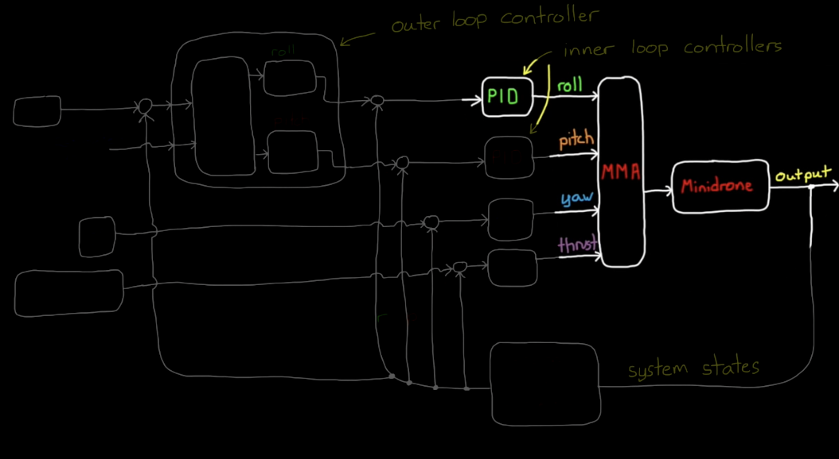This will play through the motor mixing algorithm and request that the motors on the left side of the drone speed up and the motors on the right side slowed down. This will roll the drone to the commanded angle now the drone will begin to move to the right.

But since the vertical component of thrust is slightly smaller when rolled the drone will also start to lose altitude. The altitude controller will sense this error and increase the thrust command accordingly.

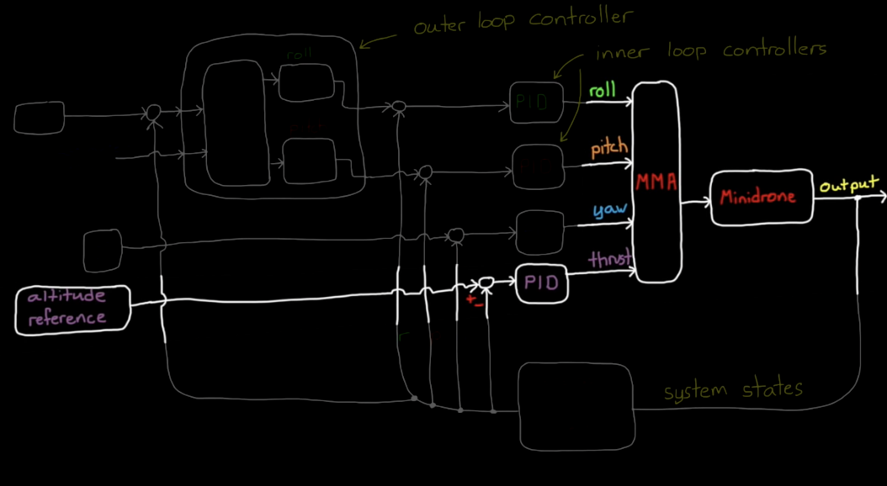Now as the drone continues moving right the position error is dropping and therefore the requested roll angle through the proportional path is also dropping bringing the drone back levelled.

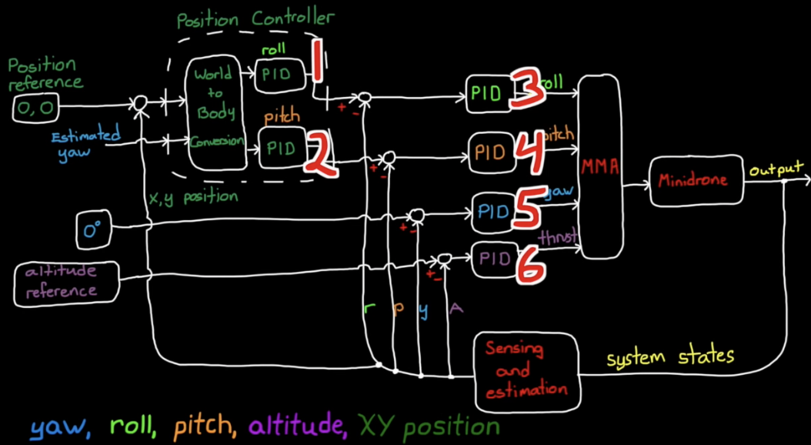

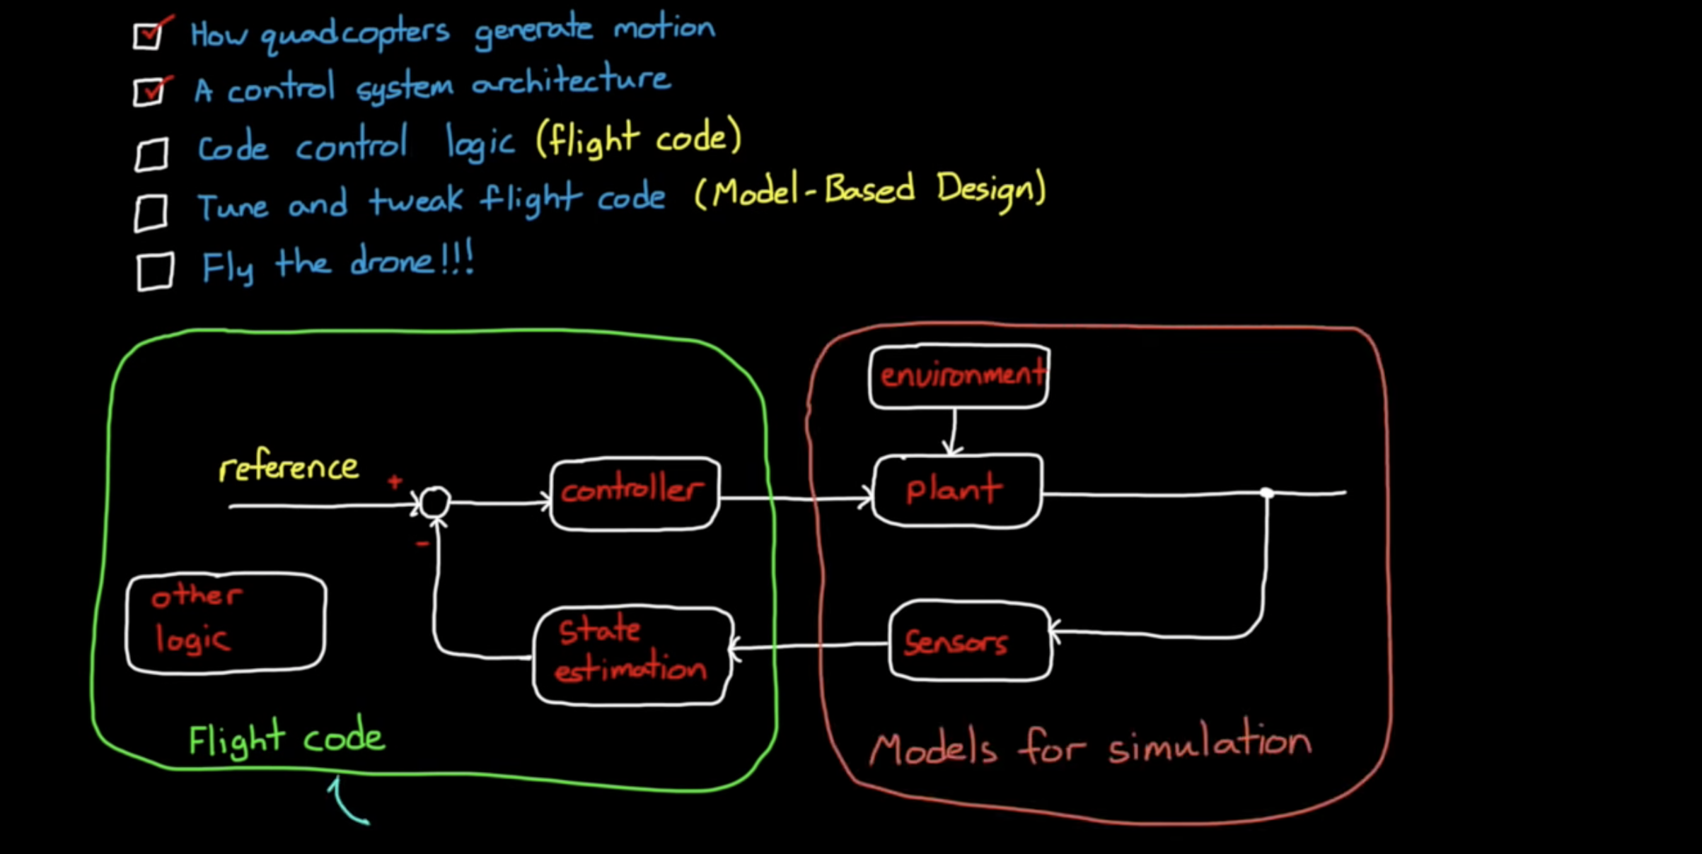

There are still a few more steps we need to take before we can actually get the drone up and hover.

# ③ The process

In order to make the drone hover, these steps are necessary:

**① Design the control architecture**: the **FCS (Flight Control Code),** is just a small part of the overall flight code that will exist on the drone. There is also code to:

* + **operate and interface the sensors**.
  + **process their measurements**.
  + manage the batteries.
  + manage the Bluetooth interface.
  + manage the LEDs.
  + **manage the motor speeds**

and the **models for simulation**!!

**②** We have a way to estimate the state's **yaw** **roll** **pitch** **altitude** and **XY position**.   
These are the 5 signals that we are feeding back into our controllers:

* We combine the measurements from the four sensors we have. We will use a **Kalman Filter** and a **common filter** to estimate each of these 5 feedback States.

**③** We need to tune **6 PID controllers** that all interact with each other.   
Specifically, 4 of them (ROLL and PITCH) are directly coupled in cascaded loops.

* 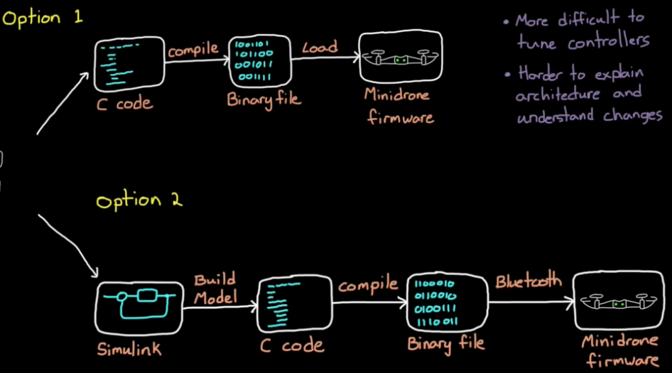We need a good model of our system so that we can use **MODEL-BASED-DESIGN** *(Option 2)* in **MATLAB Simulink** to tune our PID controllers. Then **Auto code it into C code**; if we want, we can make changes manually on the C code autogenerated and compile that C code onto the drone. The benefit of adding this extra step is that the simulant code (auto-generated) is easier to understand.  
    
  **NOTE**:   
  One option to implement the flight controller would be to write the C code by hand and then compile the entire flight code with fewer changes to the flight controller (Option 1).   
  This is a perfectly reasonable approach to create a flight code but it does have a few drawbacks when developing feedback control software:
  + we don't have an easy way to tune the controllers except by **tweaking them on the hardware**
  + we could develop our **model of the system**, then simulate how it would behave the C code that way  
      
    **NOTE**: designing and modelling control systems in C code makes it harder to explain the architecture to other people and it's more difficult to understand how changes impact the whole system than it is with just graphical methods.

**④** Code our architecture **into C with discretization and not auto coding** *(option 1 )*

# A diagram of a computer program Description automatically generatedA screenshot of a computer Description automatically generated④ Option2: Model-Based-Design – asbQuadcopterStart (Aerospace Package): The Whole Code

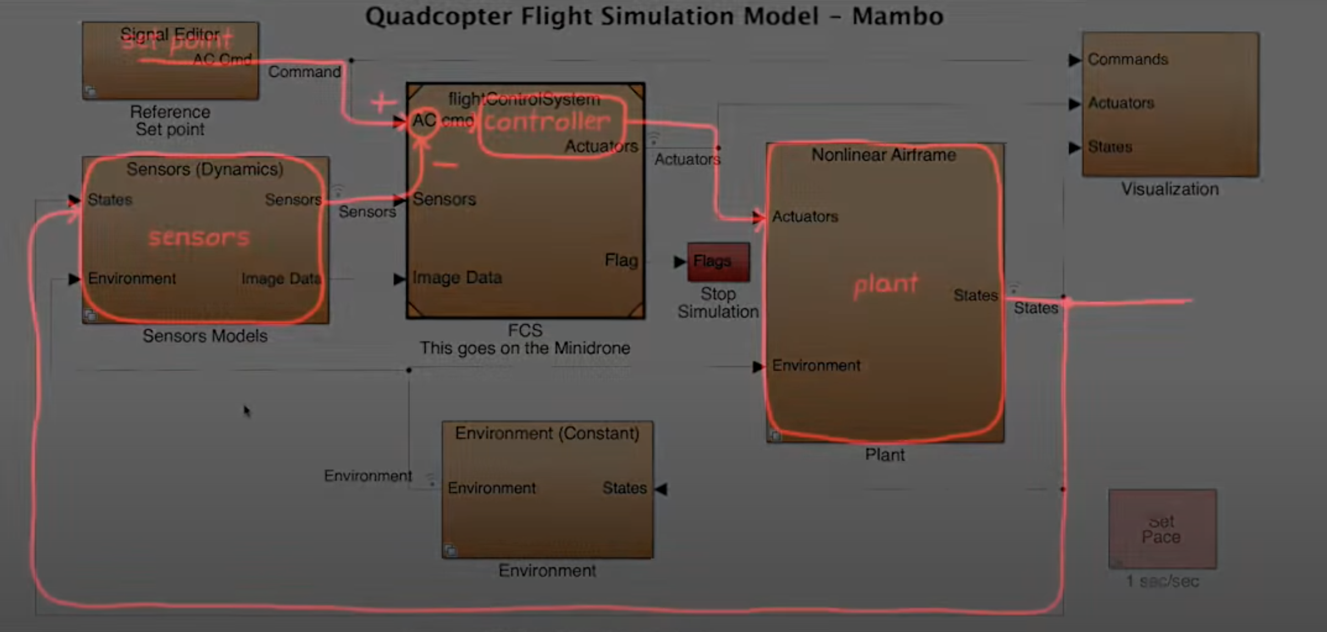

The whole Simulink model is composed by:

1. **REFERENCE SET POINT GENERATOR BLOCK**. This block, for making just the drone hovering should be inserted in the Flight Control System.
2. **FCS BLOCK**: Flight Control System: the control architecture.
3. **PLANT BLOCK**: Our G(S), with motors, dynamics etc. The plant for a work well done should have a switchable linear model (for linear control theory approach) and non-linear ( for testing our linear approach in a more complex environment).
4. **SENSOR BLOCK**: Our H(s), with sensors dynamics etc. Also for the sensors, a work well done should have a switchable mode between linear and non linear modelling, in the same approach of the PLANT
5. **ENVIRONMENT BLOCK**: This becomes more and more important in the moment we want to implement camera vision, precision landing, and robust control to disturbances. It should outputs both into sensors and plant, while its input is the y.

## ▨ asbQuadcopterStart: FCS block

The inputs of the Flight Control System are three:

1. **Set Point Generator**:
2. **Sensors**:
3. 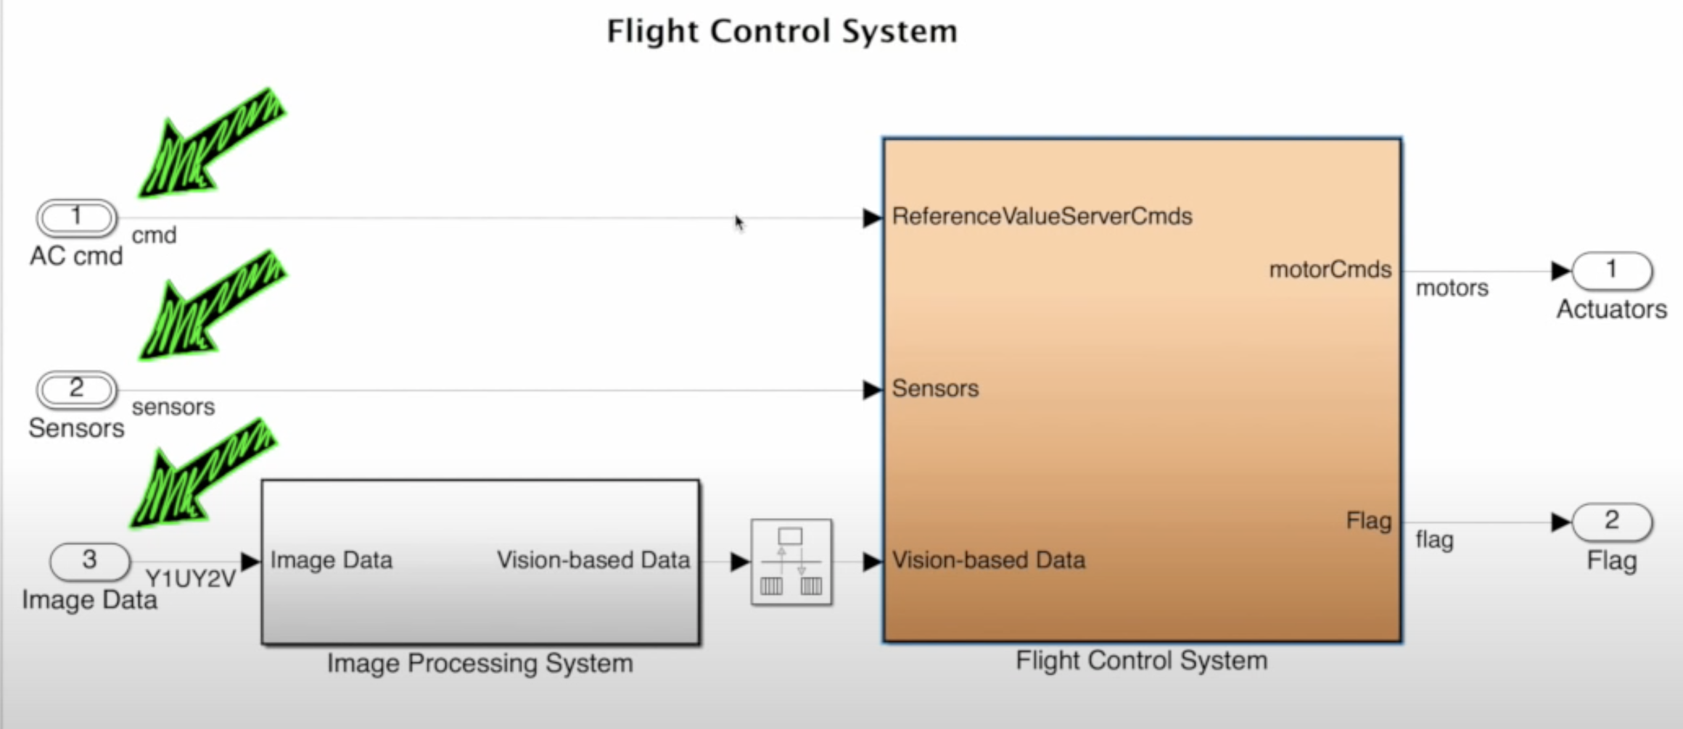**Image Data**: through the Image Processing System becomes the Vision-based Data.   
   If we do not want to consider the precision landing / travelling stuff we could start by not considering this. Other modification to the code should also be done obviously.

In order to have a functioning Flight Control System these are the 4 main subsystems we need to code:

1. **Controller block**: the cascade PIDs we already seen so far.
2. 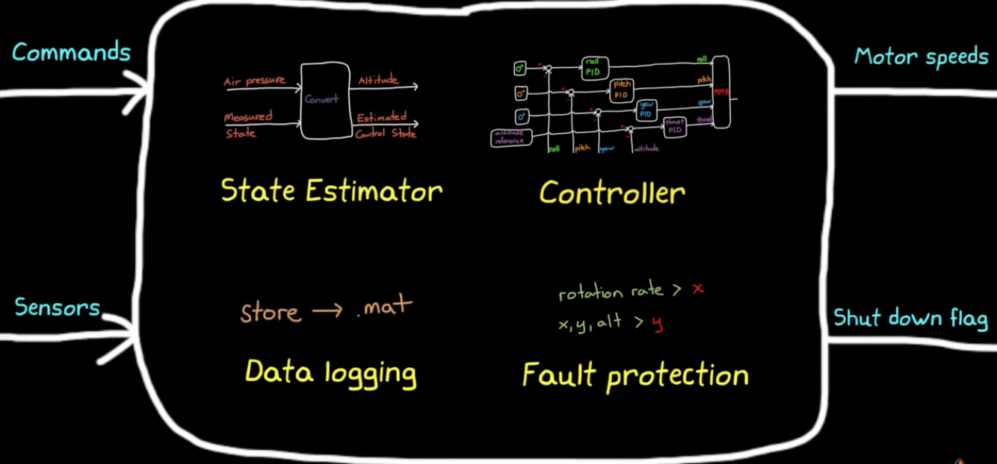**State Estimator block**: there's additional logic needed to convert all of the measured states coming from the sensors into the control States needed by the controller. We need something that would convert from air pressure to altitude for example we'll call this block the state estimator block.
3. **Fault protection block**: logic that we have to write that determines whether or not to set the shutdown flag.
4. **Landing Logic block**: (disregard for the hovering part and until we do not consider the control vision)
5. 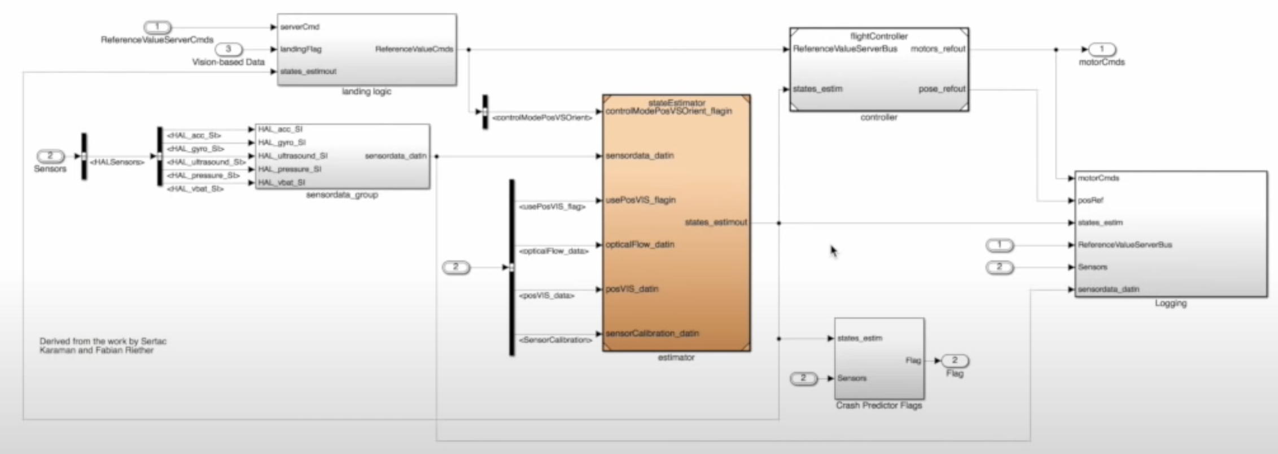**Data logging block**: all of the firmware that exists on the drone records data that we have access to during and after the flight and since the drone doesn't know about the software that we've written we need to make sure that we have data logging set for the variables that were interested.   
   → Since we'll be using Simulink to write our flight code we can easily create logic that will store data as a dot mat file locally.

CONTROLLER

DATA LOG BLOCK

Landing Logic (disregarded)

STATE ESTIMATOR BLOCK from:

* Sensor
* Camera Vision (disregarded)

FAULT PROTECTION BLOCK

### A diagram of a computer Description automatically generated▷ FCS block: Controller

This is the whole controller block, as we can see it’s divided in 4 part as in the introduction of this document:

1. **Outer Loop of Roll and Pitch that represents the POSITION XY ORIENTATION CONTROLLER** in which is also fed the YAW angle.
2. This outer loop feeds into an **ATTITUDE inner loop for controlling** that will output into the MMA for roll and pitch.
3. **YAW inner loop.**
4. **ALTITUDE (thrust) inner loop.**

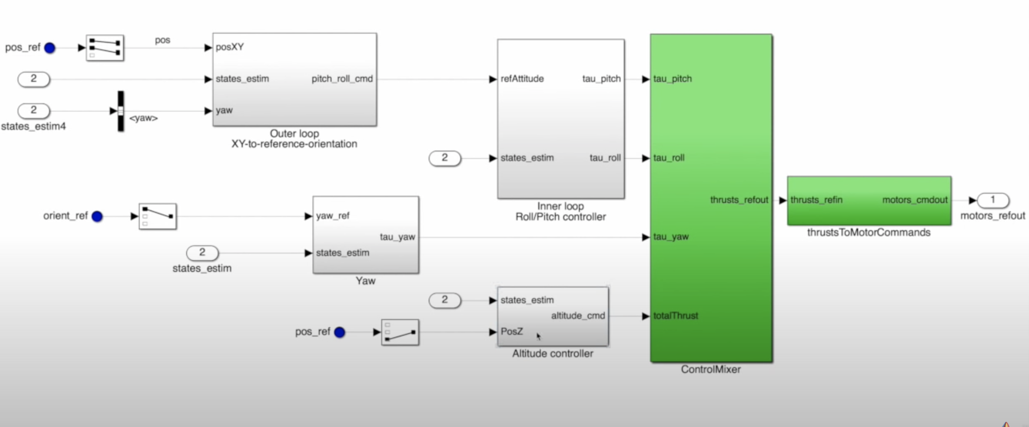[**green arrows**] There is also a logic that controls the **precision landing based on camera vision**. The precision landing interests both the altitude (obviously) but also the roll and pitch that are controlled differently the moment the landing flag is switched on.   
Being that for the simple hovering manoeuvre we do not need this, we can simplify the architecture in something like this:

#### • Inner ALTITUDE (thrust) controll

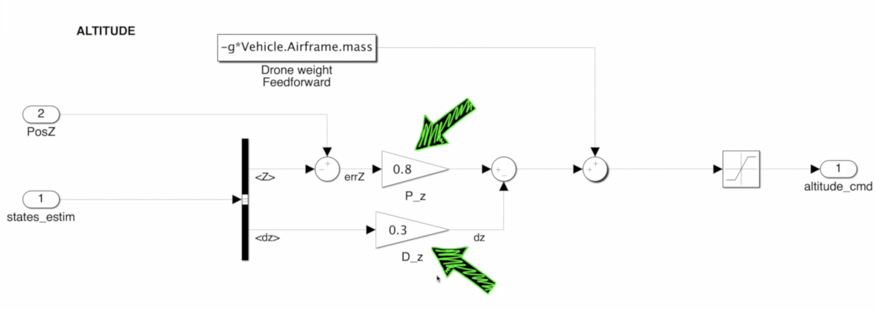

Rather than having a simple error $errZ$ feeding to both P and D branches, we have:

* + The Proportional applied to the **ALTITUDE ERROR $<Z>$ from the ULTRASOUND**
  + The Derivative instead applied to the **VERTICAL RATE ESTIMATE $<dz>$**  that comes from the KALMAN FILTERS in the estimation block.

In this way we do not have to take the derivative of a noisy altitude signal (and therefore amplifying it – defect of the PID derivative action) but instead we already have a precise / less noisy / estimation of the altitude coming from the camera vision.

(So let’s see the Kalman filters in the Estimation Block how do they work. )

#### •• Inner yaw controll

X

#### ••• Inner Roll and Pitch controll

x

#### •••• Outer (Position xy ground control) (ROll and Pitch outer Controll)

X

### ▷A diagram of a computer Description automatically generated with medium confidence FCS block: State Estimator block

STATE ESTIMATOR BLOCK from:

* Sensor
* Camera Vision (disregarded)

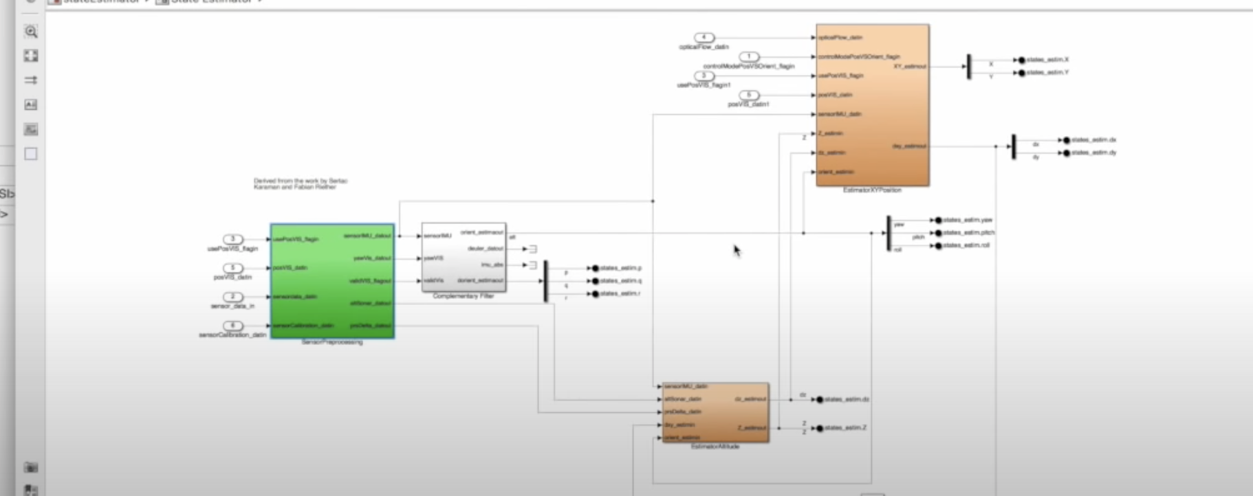There are two steps in taking the raw measurements:

②We blend the measurement together

① We process the measurements

#### • Sensor Processing

The underlying concept is that we have three kind of sensor data that must be processed differently:

1. IMU DATA
   1. Accelerometer and Gyroscope data are calibrated by subtracting the bias-sensor (previously determined).   
      The concept is that when there is 0 acceleration and 0 angular rate, than the measurement should be also 0.
   2. Then we need to rotate the IMU data because of z axis for the drone is directed downwards.
   3. Then we need to apply a low filter pass in order to remove the high frequency disturbance.
2. ULTRASOUND
   1. It’s just enough to remove the bias as done with the IMU.
3. OPTICAL CAMERA VISION DATA
   1. 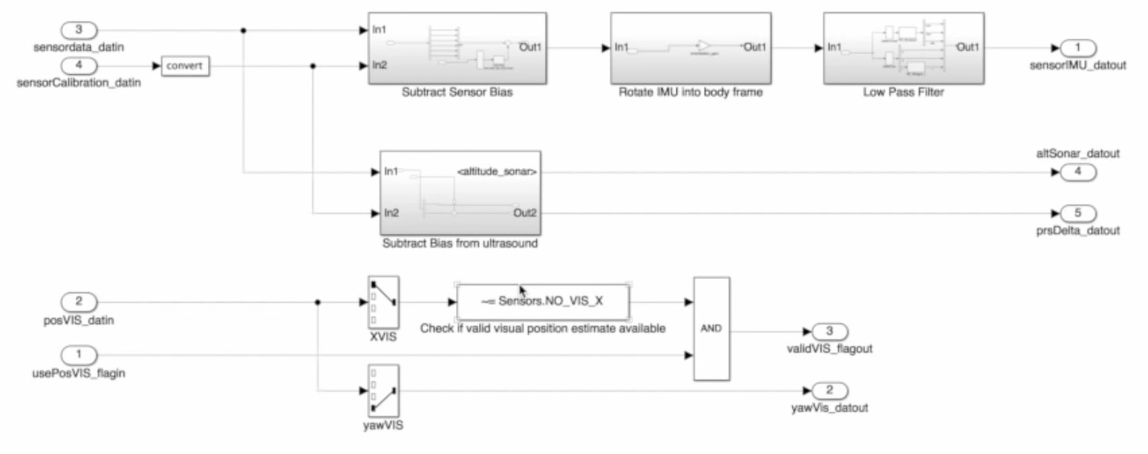We implement a PASS/FAIL logic, that if it has a valid position estimate, than we want to use that estimate and a flag is sat to true.

#### •• Blending the measurements together

We have three kind of estimates to do for a total of 5 signals:

|  |  |  |  |  |
| --- | --- | --- | --- | --- |
| **X,Y position** | **Z altitude** | **ROLL** | **PITCH** | **YAW** |
| KALMAN FILTER | KALMAN FILTER | COMPLEMENTARY FILTER | | |
| <https://it.mathworks.com/videos/understanding-kalman-filters-part-1-why-use-kalman-filters--1485813028675.html> | | <https://www.youtube.com/watch?v=whSw42XddsU> | | |

### A diagram of a flag Description automatically generated▷ FCS block: Fault protection block

### ▷ FCS block: Landing Logic block

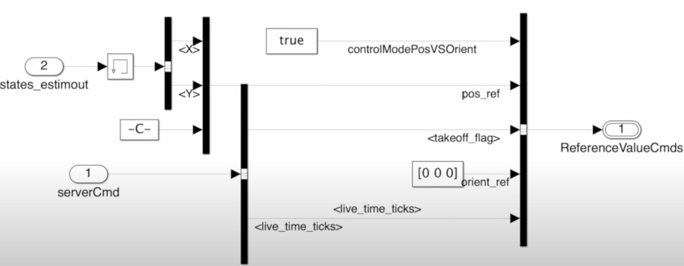This block will overwrite the external setpoint commands with landing setpoint commands.

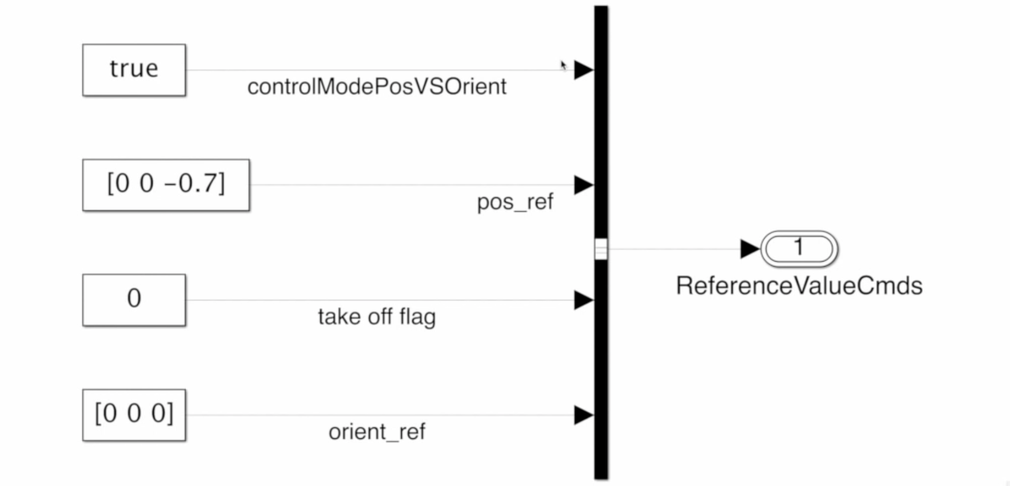For the hovering purpose we could rewrite this block as a “set point generator block” to make the drone hover at 0.7meters at the starting point.

### A screenshot of a computer Description automatically generated▷ FCS block: Data logging block

## ▨ asbQuadcopterStart: DRONE DYNAMICs block

Part 4 and 5 non linear and linear modelling : <https://www.youtube.com/watch?v=gEmGfo36INc&t=115s>

## ▨ asbQuadcopterStart: SENSOR DYNAMICs block

x

## ▨ asbQuadcopterStart: ENVIRONMENT block

x